**20June22**

*BO1*

File -> gga-2001-12-31_f0031.txt

Time: correct

Gas temp: 22.56c

Gas Pressure: 140.41 Torr

Laser AI: 3.79 microS

Laser BI: 3.12 microS

First Run -> 11:22:30-11:28:00

Air: 11:28:00-11:29:00

Second Run-> 11:29:00-11:35:00

Air: 11:35:00-11:36:00

Third Run -> 11:36:00-11:44:00

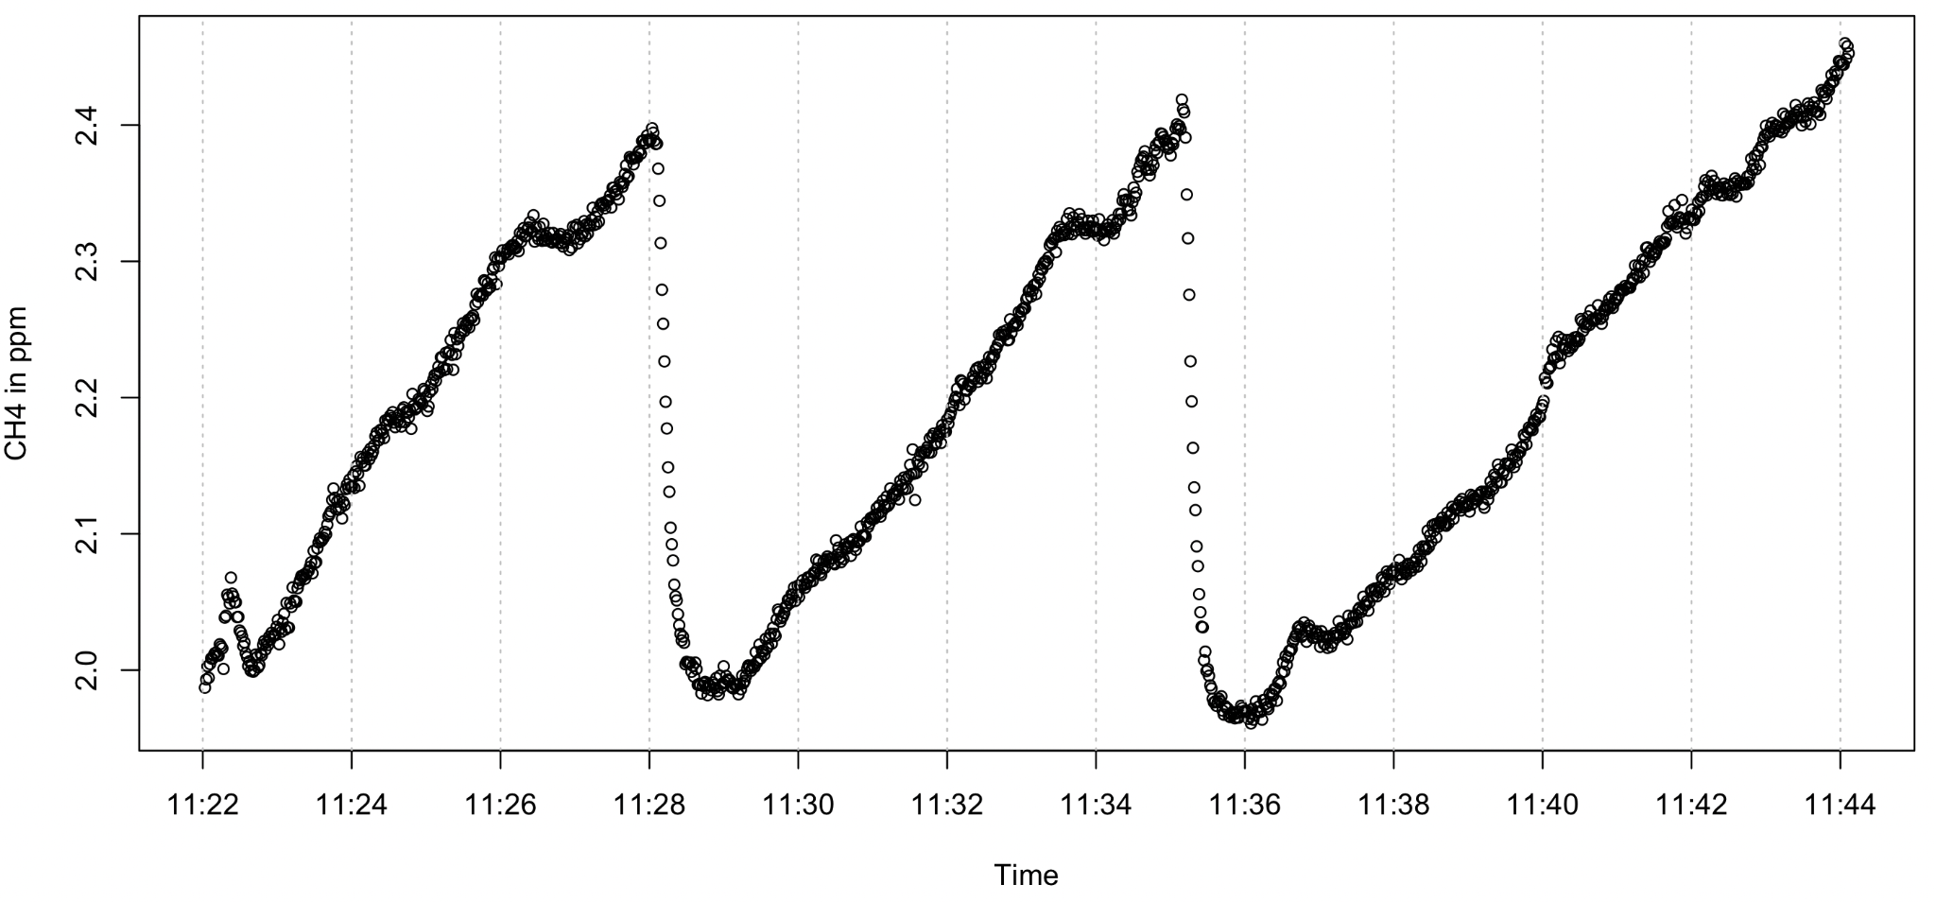

*B50*

File -> gga-2001-12-31_f0032.txt

Time: Correct

Gas Temp: 25.47c

Gas Pressure: 140.36 Torr

Laser AI: 3.79 microS

Laser BI: 3.14 microS

Air: 12:04:00-12:06:00

1st Run: 12:06:00-12:14:00

Air: 12:14:00-12:15:00

2nd Run: 12:15:00-12:23:00

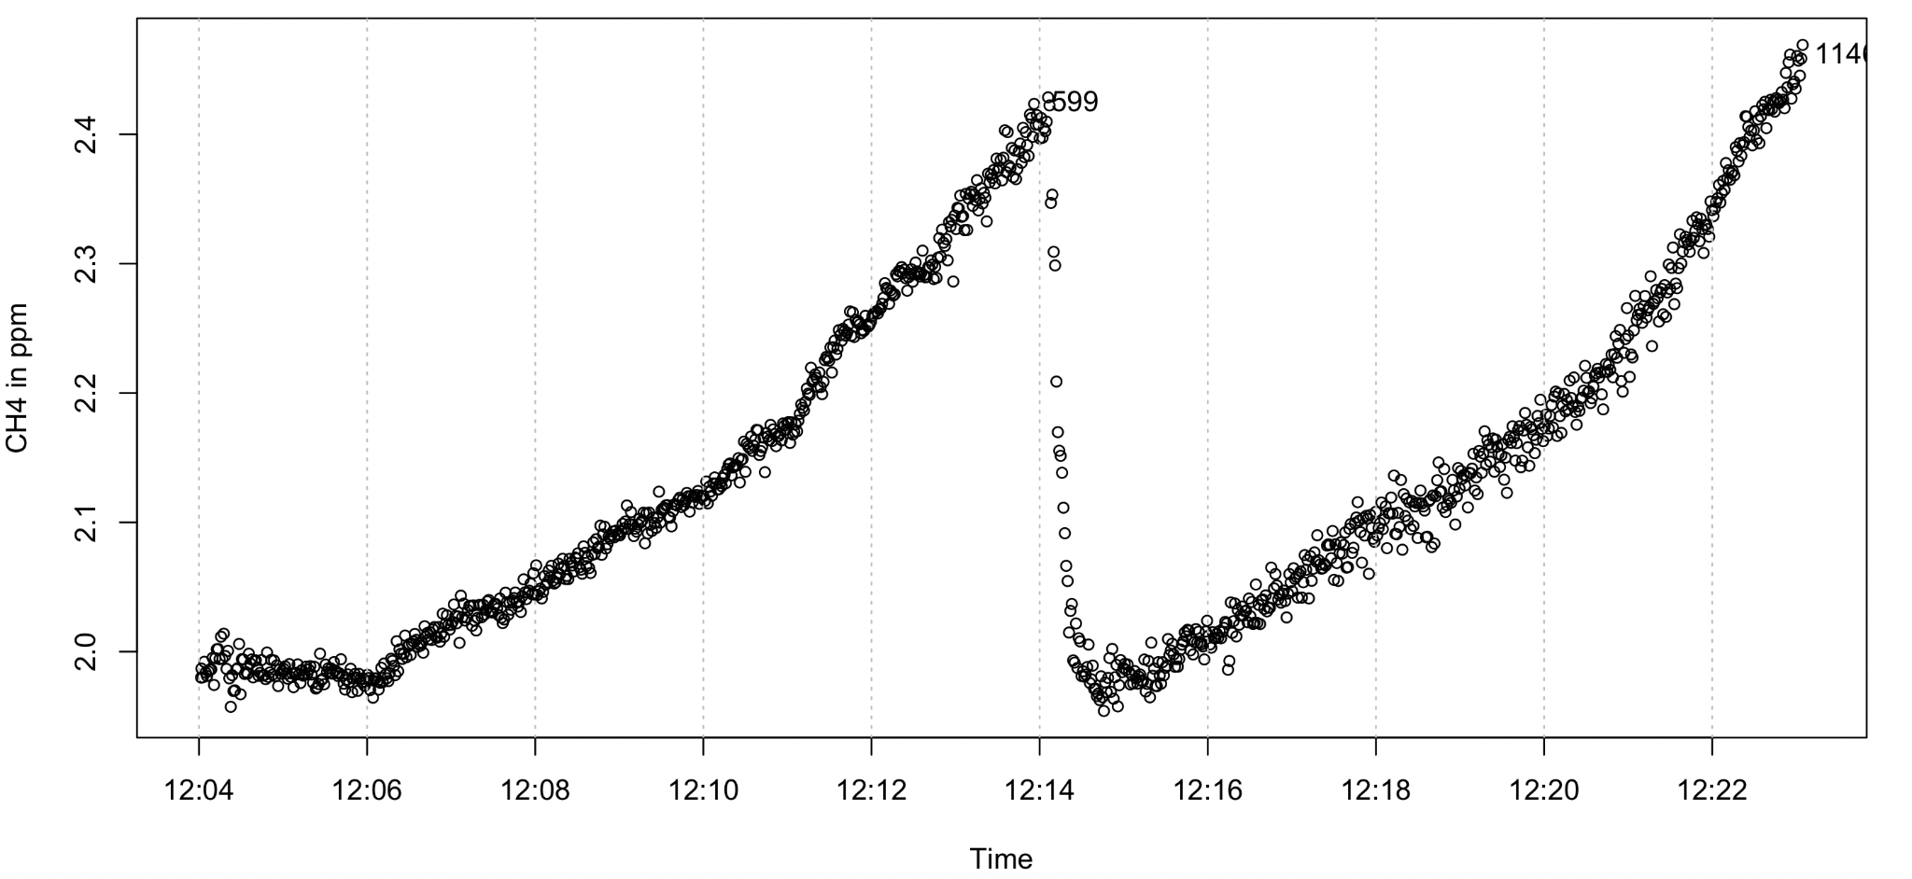

F30 someone is in the process of setting the time

F29 is literally one data point

F28 is random noise

F0027 (b50)–F0023 are from June 13

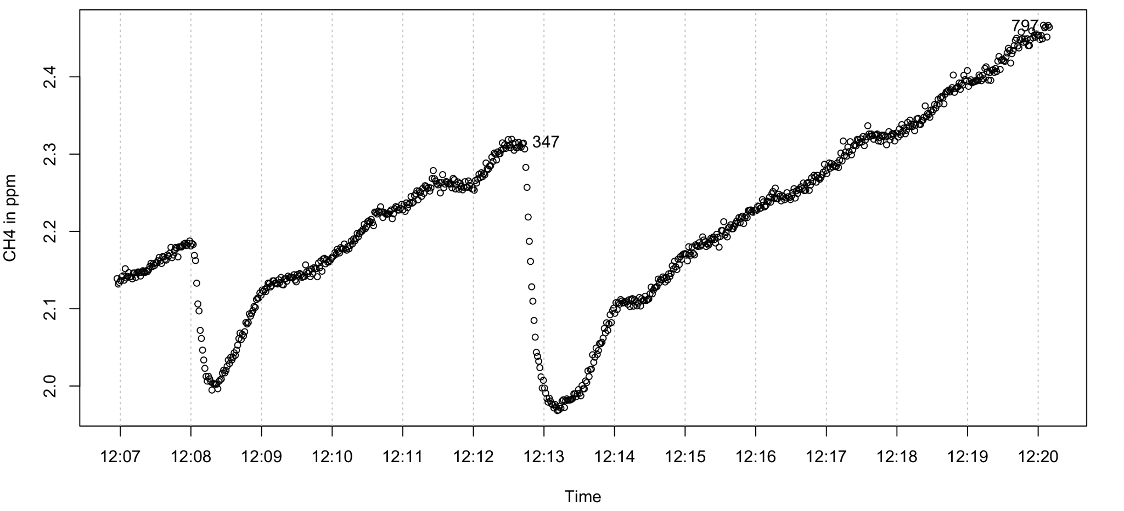

* F0027 is real (b50)
* There is an issue with F0026 (tiny data file)
* F0025 is just one upward line for 7 minutes (b01)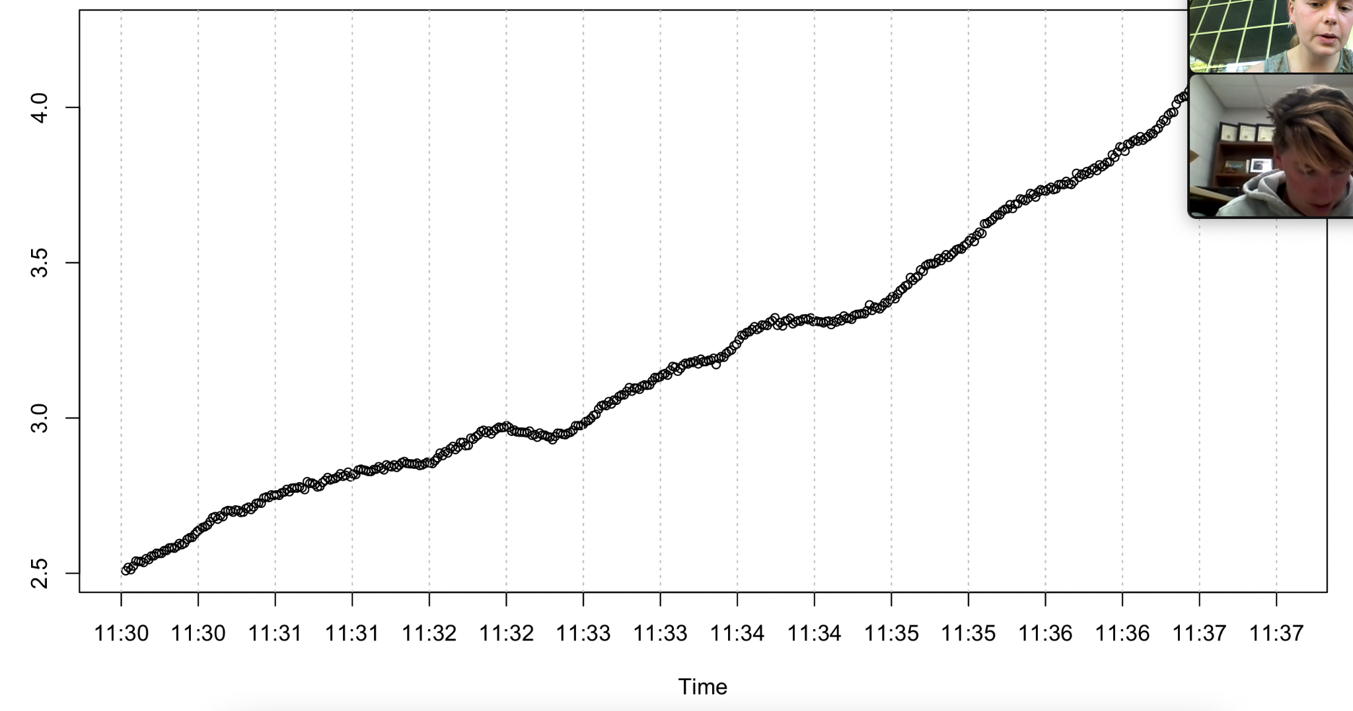
* F0024 is also one upward line (b01)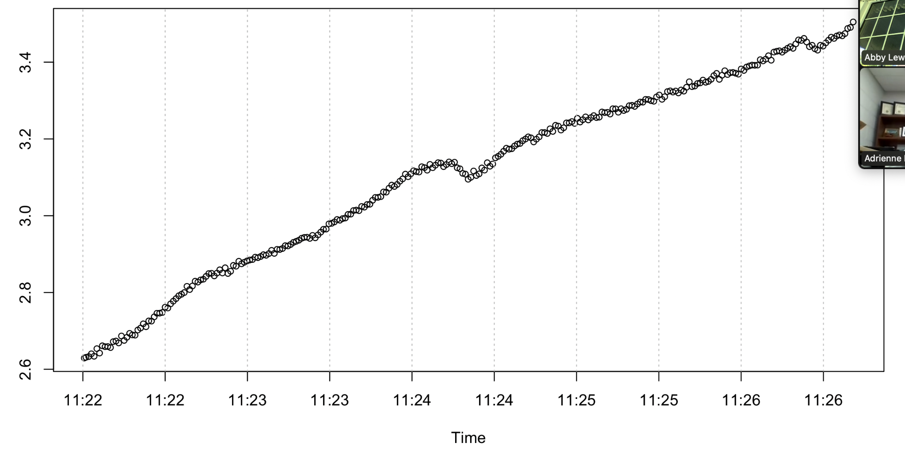
* F0023 is also one upward line (b01)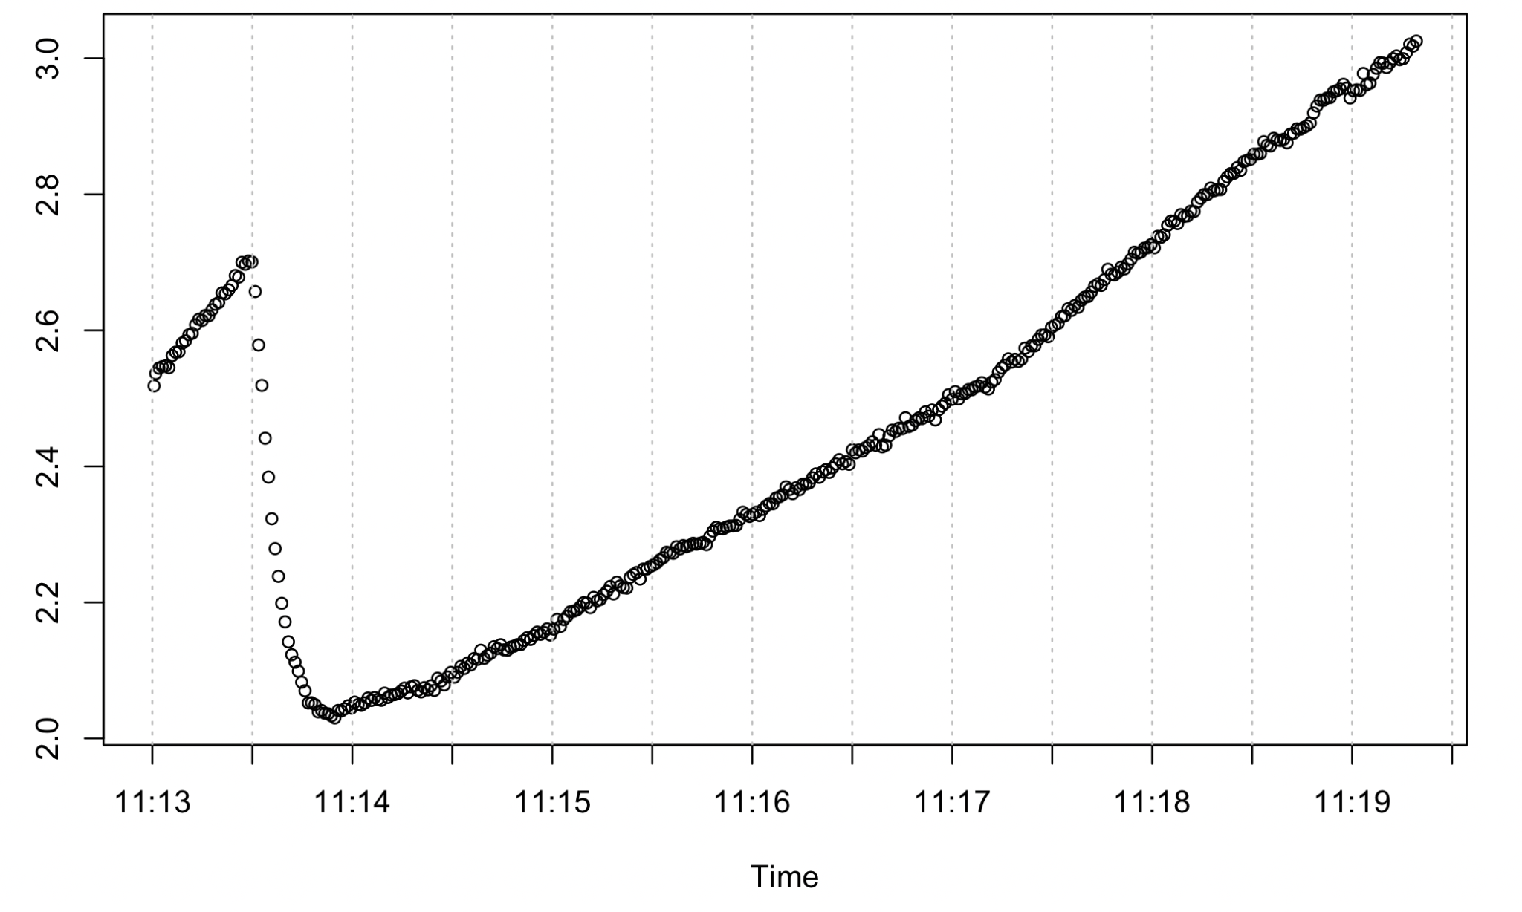

F0022 is June 10 (UGGA cleaning day), but only 30 seconds of data

* F0021 is also June 10 (5 min of random noise)

F0020 is an upward trend (B50)

F0019 is two peaks! Real data! (B01)

F0018 is also two peaks (B50)

F0017 has a plateau and then two peaks (B01- I think I remember this)

No UGGA sampling on May 24

F0016 has two peaks

F0015 has two peaks

F0014 is messy and short

F0013 has two very different peaks

F0012 seems mostly real. Turned off before going back to baseline, but I think I remember heather doing this

F0011 has two peaks

F0010 is beautiful (two peaks)

There is an issue with F0009 (tiny data file)

F0008 is short and random noise

F007 looks like cleaning